Programmer Guide
Main purpose of code:
The main purpose of this code is to allow a user to connect and login to a database and allow them to run multiple queries pertaining to that database. A main menu is shown with options to run one of five queries or exit the program. After a query is selected, different information pertaining to the database will be displayed and the user will be redirected to the main menu.

Methods:
The purpose of this method is to read in the database name from user input. This method will store that user input in a variable to be returned as a string. The method has no parameters.

The purpose of this method is to read in the database username from user input. This method will store that user input in a variable to be returned as a string. The method has no parameters.

The purpose of this method is to read in the database password from user input. This method will store that user input in a variable to be returned as a string. The method has no parameters.

The purpose of this method is to display a menu of options with simple instructions to navigate the menu. This prints a series of lines displaying a six-option menu with instructions on the top that tells the user to input a number to select one of the six options. Options one through 5 are all queries that will be run if selected. Option six will exit the program. The method has no parameters and return type void.

The purpose of this method is to run the first query. For this specific query a user is asked to enter a product id and then it displays supplier information from all the suppliers that supply that specific product. The code begins by prompting the user to enter in the product id placing it in a string variable. Next the code creates another string variable to hold the actual query itself. The query compares all the supplier ids from the SQL table named “Supplier” and the supplier ids in the “ProductSupplier” table that correspond with the user input. After finding the common ids, it will select out the supplier id, street, city, state, and zip of those ids for output. The following code after the query creates a prepared statement object. This is used to prevent SQL injection attacks by the user since it precompiles the SQL code. Using the prepared statement object, we add the user input to the query and then execute the query. A while loop is used to run through each line of the SQL output and display it out in table format for the user. The loop ends when there are no more results left to read. The “query1()” method has a return type void and takes in a connection object as a parameter. There is a “throws SQLException” after the method in case there is an error with the interaction of the SQL data.

The purpose of this method is to run the second query. For this specific query a user is asked to enter a product price and it displays the product id and supplier id for any product that costs less than that specified price. First user input is stored in a string variable. Next another string variable is made to hold the query itself. This query will compare the product ids from the “Product” table with the ids in the “Product Supplier” table, selecting those shared. It then takes the selected ids and checks if the cost of these products is lower than the user input. Those that are, will have the product id and supplier id selected for output. Next a prepared statement object is created. This is used to prevent SQL injection attacks by the user again. Using this prepared statement object, we add the user input to the query and then execute the query. A while loop is used to run through each line of the SQL output and display it for the user.
The “query2()” method has a return type void and takes in a connection object as a parameter. There is a “throws SQLException” after the method in case there is an error with the interaction of the SQL data.

This method runs the third query. The purpose is to find the customer or customers that have ordered the greatest number of widgets. It then displays this customer/customers’ information for the user along with the order quantity. First a string variable is made to hold the third query. This query joins the “CustomerWhWidget” table with the “Customer” table on customer ids. Using an aggregate function of max, it finds the customer with the largest order quantity. The customer id, first name, and order quantity are then set to output. It is possible to select multiple customers if there is a tie in order quantities. A prepared statement object is created, and the query is executed. A while loop is used to run through each line of the SQL output and display it for the user. The “query3()” method has a return type void and takes in a connection object as a parameter. There is a “throws SQLException” after the method in case there is an error with the interaction of the SQL data.

This method runs the fourth query. The purpose of this query is to find any widget with no customer orders and display its information for the user. The code first creates a string variable to hold the query. This query takes all of the widget ids from the “Widget” table and checks to see if they are in “CustomerWhWidget” table. Any widget id that is not in that table is selected from the “Widget” table. Those selected ids are then used to pull the widget id, weight, name, and cost from the “Widget” table for output. It is possible to have multiple widgets with no customer orders. A prepared statement object is created, and the query is executed. A while loop is used to run through each line of the SQL output and display it for the user. The “query4()” method has a return type void and takes in a connection object as a parameter. There is a “throws SQLException” after the method in case there is an error with the interaction of the SQL data.

This method runs the fifth query. The purpose of this query is to select every widget and display the total amount of that widget that was ordered by customers. The code creates a string variable to hold the query. This query will create a left join between the “Widget” table and the “CustomerWhWidget” and group by widget ids. It will then take the order quantity for each widget and add them using an aggregate function of sum. If there are no orders for a widget then it will set the order quantity to zero from null. A prepared statement object is created, and the statement is executed. A while loop is used to run through each line of the SQL output and display it for the user. The “query5()” method has a return type void and takes in a connection object as a parameter. There is a “throws SQLException” after the method in case there is an error with the interaction of the SQL data.

The code in main begins by using a try and catch statement to check for a mysql driver. If the driver cannot be loaded, then a print statement will execute detailing that. Next another try statement will run which holds the actual main portion of the code. In this statement a connection object is created to allow for the connection of an SQL database. A connection is established after having a proper database name, username, and password. These will be entered in by calling the “userDatabase()”, “userName()”, and “userPassword()” methods. The next portion of the code deals with the user interface and allowing them to run queries. The “showMenu()” method is called and a while loop will run. The while loop will run query methods corresponding with the user input. This will continue until they enter the number six to exit. If during the initial try statement, the program is unable to connect to the database then it will drop to the next catch statement which will print out “Can’t connect to database” and detail the reasoning for the error. There is another catch statement that will print out “Other Error” in case this is not the reasoning for the inability to connect to the database.

Test Plan
Connection to database:
Testing the user input for connection object in main along with userDatabase(), userName(), and userPassword(). Entering valid database name along with the username jmunoz13 and password 1073184. Should result in a proper connection established prompt and a user menu to appear on the display.

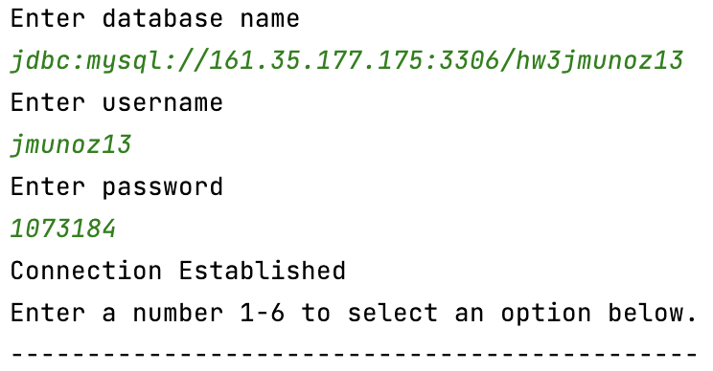
Valid credentials resulting in connection.

Using proper database name but incorrect username and password should result in an access denied prompt to appear along with a cannot connect to database prompt.

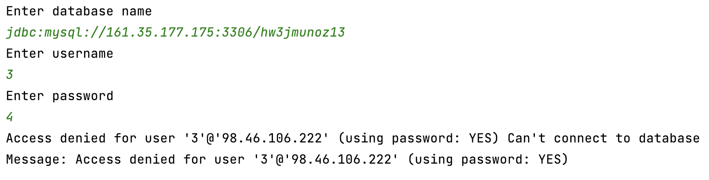
Incorrect username and password will result in no connection.

If an incorrect database is entered, then output should prompt that no suitable driver for that database was found along with the cannot connect to database prompt.

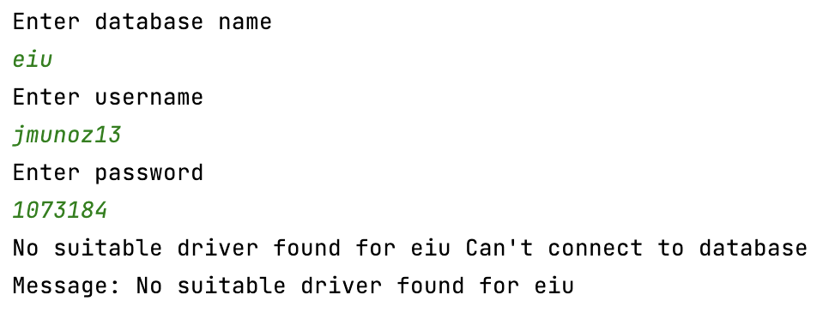
Incorrect database name resulting in no connection.

Menu Traversal:
Entering the number 1 should result in a “processing results” output and a prompt asking for a product id to be entered. Following that prompt, the main menu should output again. Entering the number 2 should result in a “processing results” output and a prompt asking for a product price to be entered. Following that prompt, the main menu should output again. Entering the number 3 should result in a “processing results” output and the results for that query. Following that prompt, the main menu should output again. Entering the number 4 should result in a “processing results” output and the results for that query. Following that prompt, the main menu should output again. Entering the number 5 should result in a “processing results” output and the results for that query. Entering the number 6 should output “Ending session.” and end the program. Entering any integer that is not 1-6 should result in the main menu to be output again until a valid number is entered.

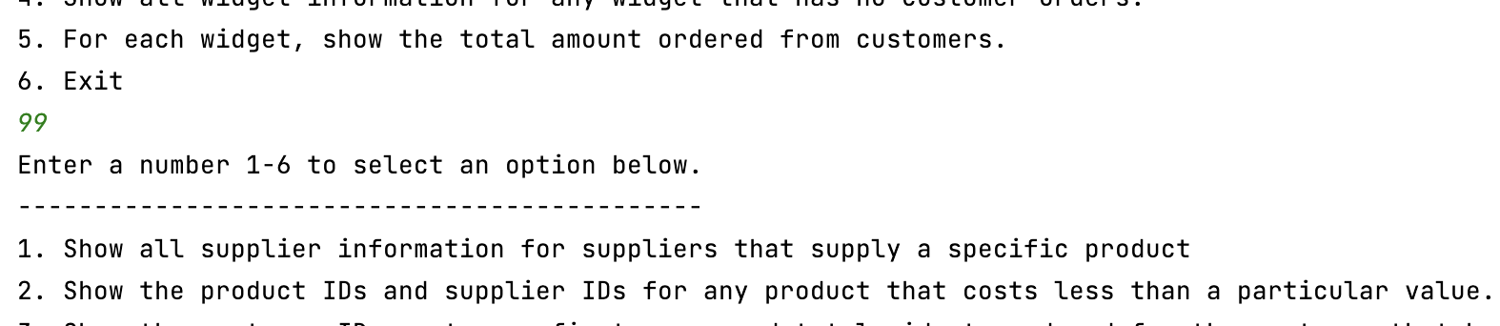
Integer 99 entered resulting in the main menu to be prompted again.

Query 1:
For query 1, entering product id “573” should result in the “Processing Results” output, followed by a single line showing “Supplier id: 450 | Supplier Street: 6165 Shopko Junction | Supplier city: Akron | Supplier state: Ohio | Supplier zip: 44321” and then the menu prompt. Entering product id 574 should result in the “Processing Results” output, followed by two lines showing “Supplier id: 450 | Supplier street: 6165 Shopko Junction | Supplier city: Akron | Supplier state: Ohio | Supplier zip: 44321 Supplier id: 451 | Supplier street: 05 Heffernan Way | Supplier city: Asheville | Supplier state: North Carolina | Supplier zip: 28815” and then the menu prompt. Entering product id “999” will result in “Processing Results” output, followed by no other output besides the menu prompt.

Query 2:
For query 2, entering product price “.05” should result in the “Processing Results” output, followed by a single line showing “Product ID: 661 | Supplier ID: 450” and then the menu prompt. Entering the product price “.06” should result in the “Processing Results” output, followed by three lines showing “Product ID: 575 | Supplier ID: 450 Product ID: 575 | Supplier ID: 452 Product ID: 661 | Supplier ID: 450” and then the menu prompt. Entering the product price “.01” should result in the “Processing Results” output, followed by no other output besides the menu prompt.

Query 3:
Query 3 requires no additional user input. “Processing Results” outputs immediately followed by the results. In this current state with the database, the output should be 2 lines showing “Customer Id: 258 | Customer First Name: Goldy | Order quantity: 5 Customer Id: 259 | Customer First Name: Andromache | Order quantity: 5” followed by the menu prompt. In this case there are multiple lines of output since the status of the tables include two customer quantities that both have the highest order quantity. If only one customer had the highest order quantity in “CustomerWhWidget” table, then it should result in only one line of output.

Query 4:
Query 4 requires no additional user input. “Processing Results” outputs immediately followed by the results. In this current state with the database the output should be one line showing “Widget id: 601 | Widget weight: 10lbs | Widget name: Power Saw | Widget cost: 50.0” followed by the menu prompt. In this case there is one line of output since the status of the tables has only one widget with no customer orders. If there were multiple widgets with no order quantity in the “CustomerWhWidget” table, then there would be multiple outputs. If all widgets had an order quantity in that table, then there would be no output.

Query 5:
Query 5 requires no additional user input. “Processing Results” outputs immediately followed by the results. In this current state with the database the output should be 6 lines showing “Widget Id: 234 | Amount Ordered: 10 Widget Id: 374 | Amount Ordered: 2 Widget Id: 375 | Amount Ordered: 3 Widget Id: 475 | Amount Ordered: 1 Widget Id: 574 | Amount Ordered: 1 Widget Id: 601 | Amount Ordered: 0” followed by the menu prompt. In this case there are multiple lines of output since the status of the tables include multiple widgets. If there was only one widget in the joined “Widget” and “CustomerWhWidget” table, then there would be one line of output. Likewise, if there were no widgets in the table then there would be no output.

